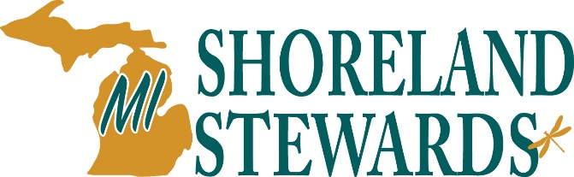
[ Lake Association Logo ]

The Smith Family
123 Lake Street
Lake City, MI

Dear Lakefront Property Owner,

Hello! My name is (your name) and I am a Michigan Shoreland Stewards Ambassador for (name of lake). The Michigan Shoreland Stewards Program (MiSS) is a program of the Michigan Natural Shoreline Partnership (MNSP). This statewide program was created to recognize lakefront property owners for maintaining shoreland property in a manner that reduces negative impacts on inland lake. The program has an online educational survey to help lakefront property owners assess their shoreland management practices, as well as get advice on how to be a good steward of your lake.

As a MiSS Ambassador, I wanted to reach out and invite you to join me in making our lake healthier and even more beautiful. I encourage you to visit the MiSS website at www.mishorelandstewards.org and take the survey! I would be happy to assist you or answer any questions. You can reach me at email or (xxx) xxx-xxxx.

Thank you for all you do for our lake!

Best,
Your Name

